Mehmet Izol

Professor Cleveland

COMP 3324

Lab 5 – Tripwire on Linux

3/12/2023

Tripwire setup on Linux

(here Debian Linux is used)

Image:

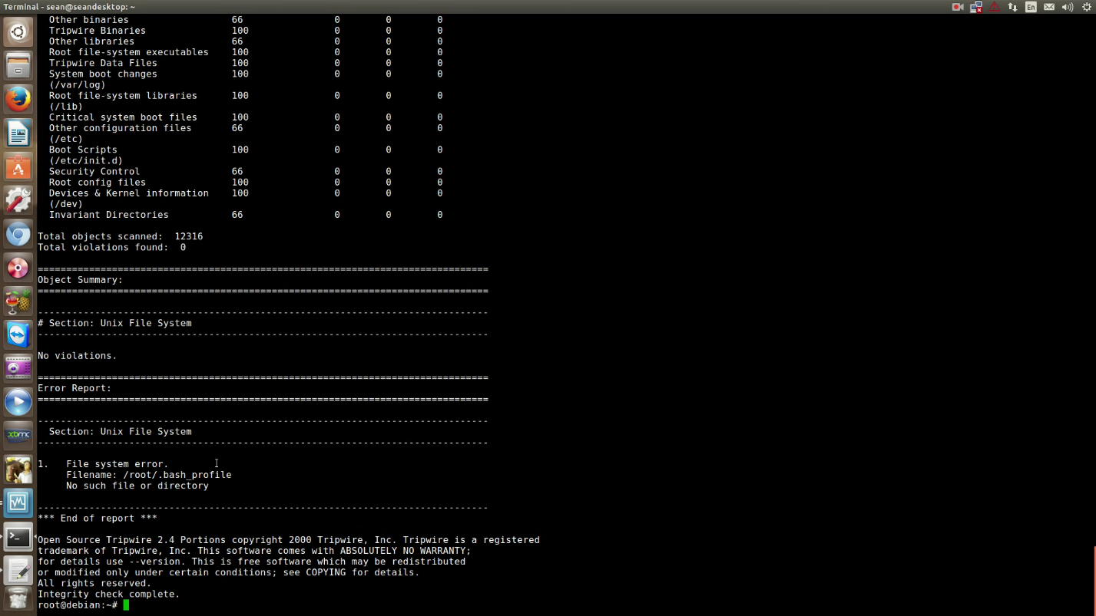

What new I learned:

* Here is used Debian Linux on the laptop of Sean. Azamat and I did it together. I do not have any Linux, that is why, we solved this homework problem together with Azamat on the Laptop of Sean.
* Tripwire is a software security for notifying any changes on the PC, and monitoring changes on files, systems.
* Finally, 0 violations were found at the end of the command:
  + - “tripwire --check”.